**JQuery and Ajax**

**Key Points about JQuery** :-

********************

1. It is Small/light weight library of javascript.
2. It follows the concept of **WLDM ( Write less do more )**

JQuery can be Added in project to perform javascript operation at less, link of code.

**There are two ways of using Jquery** –

1. Local linking
2. Using CDN links
3. Jquery is more about, DOM ( Document Object Model) Manipulation.

**General Syntax of JQuery is** –

**********************

1. **$(selector).EventMethod(**Anonymous function or callbacks**).**

**JQuery Library file comes in 3 forms**

1. Uncompressed (code : read , size larger)
2. Minified (code : not read , size smaller)
3. Slim ( code : not read, size smaller)

**Order of size** : -

**slim < minified < uncompressed.**

In slim file Ajax code is removed.

**minified** : Ajax code include.

**Uncompressed :** Ajax code include.

Javascript

1. Synchronous and Asynchronous

**AJAX : Asynchronous Javascript and Xml ( Yml , Json)**

**CDN LINK –** <https://code.jquery.com/jquery-3.6.3.js>

CDN (Content Delievery Network)

For checking cdn is connect or not —– CRTL + U

    <script type="text/javascript"  src="https://code.jquery.com/jquery-3.6.3.js"></script>

    <script>

       //   code written

        function $(selector = '' )

        {

             return document.querySelector(selector);

        }

        // calling the function

           window.alert(fun('document'));

    </script>

First.code –

<!DOCTYPE html>

<html lang="en">

<head>

    <meta charset="UTF-8">

    <meta name="viewport" content="width=device-width, initial- scale=1.0">

    <title>Jquery</title>

</head>

<body>

    <h1>Skeleton of JQuery Script</h1>

<!--Hmesa body ke just uper hoga -- head me nahi lagana hai.-->

<script type="text/javascript"src="https://code.jquery.com/jquery-3.6.3.js"></script>

    <script>

        function $(selector = “ ” )

        {

             return document.querySelector(selector);

        }

        // calling the function

           window.alert($('document'));

            //   window.alert($('h1'));

    </script>

</body>

</html>

**JQUERY SYNTAX –**

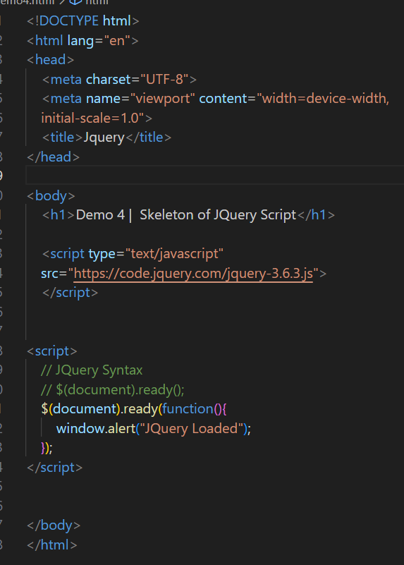

**Javascript Event** –

onclick

onmouseover

onmuseout

onchange

onDblclick

…..

….

onload

**In JQuery Remove : on**

onclick => click

onchange => change

onmouseover => mouseover()

onmouseout => mouseout()

Lowercase => camelCase or lowercase

**Javascript –**

document.getElementById() => #idname

document.getElementByClassName() => .className

document.getElementByTagName() => Tagname

**Javascript –**

Text get : innerText => .text()

Tag with Text : innerHTML => .html

**Javascript Style –**

.style.propertyName

.css(propertyName, value)

.css ()

**In JQuery me –**

function(inside) 🡺 for set

function() 🡺 get

**e.g –**

a(“soni”) 🡪 set

a() 🡺 get

**In javascript, For Attribute –**

elementName.attributename

**JQuery –**

attr(‘src’, ‘1.jpg’); 🡺 set.

attr(‘src’) 🡺 get

**Forms in Value –**

.value 🡪 js

.val() 🡺 get in Jquery

.val(“soni”) 🡺 set in jquery

**[Null Coelascing Operator ]**

**p1.php**

<?php

#WAP in php to show nullcoelascing operator. {value is set or not}

$x = 10;

echo $x;

echo $c; //undefined index $c notice error.

echo PHP_EOL; // echo “\n”; , echo “<br/>”;

$c = 200;

$c = isset($c)? $c: null; // using Ternary Operator

// $c = isset($c)? true: false;

$c = isset($c)??$c;

echo $c;

var_dump($c);

?>

🡺**Spaceship Operator** ––––> *5<==>6*

**Short Notes Of JQuery** –

**JQuery – Light library for Javascript**

**Any Task done in Javascript in Large Number of Lines**

**Same Task can be performed using JQuery in less no of lines.**

**Main Aim** :- **Write less do more.**

**Flavours of JQuery** :

1. Core JQuery : you will just get core JS file.
2. JQuery UI : core Js + UI + CSS. (JQuery Plug).

**How to link JQuery Link :-**

1. Using cdn link
2. Using local file

**Blue Print of JQuery :-**

<?php

?>

**$(document).ready(function() {**

**//any code…..**

**});**

**When – Page loading is finished, then run our event.**

$ () => selector

Ready () => event

$(‘selector’).event(function() {

});

**JQuery JS Files Type** –

1. Uncompressed : size larger : readable : loading time large.
2. Compressed (minified) : smaller in size : all enter and spaces are removed size smaller. Loading time less.
3. Slim : uncompressed file with Ajax code is removed.
4. Slim : minified : compressed without Ajax code.
5. **Using cdn link –**

**<body>**

**<script type=”text/javascript” src=”JQuery-wala-link”>**

**</script>**

**<script>**

**$(document).ready(function () {**

**window.alert(‘JQuery loaded….’);**

**});**

**</script>**

**</body>**

**CDN –** ***Content Delivery Network***

This will work only when internet connection available.

But, for the first time : internet connection

If hard refresh : JQuery will be loaded from cache memory.

**Otherwise :** Error : $ declaration is undefined.

1. **Using locally link –**

Download the file and keep in the same folder.

**<body>**

**<script type=”text/javascript” src=”js/jquery.js”>**

**</script>**

**<script>**

**$(document).ready(function () {**

**window.alert(‘JQuery loaded from Local….’);**

**});**

**</script>**

**</body>**

**How to Target in JQuery –**

**In JS we target using**

1. document.getElementById() => id
2. document.getElementByClassName () => className
3. document.getElementByTagName () => TagName
4. document.querySelector () => CSS selector target one Element
5. document.querySelectorAll () => CSS Selector target All Element

**Targetting In JQuery** –

1. $(“css selector”) or $(‘css selector’)

**Types of CSS Selector** –

1. Tag Selector : P, div, input, span, form, h1, h2, h3…..n of Tags.
2. Id selector : #id
3. Class selector : .className
4. Compound selector

<div>

<ul>

<li>maggie</li>

<li>Tea</li>

<li>Coffee</li>

<li>Somosa</li>

</ul>

</div>

$(“ul”) 🡺 2nd wala target

$(“div ul”) 🡺 ul inside div tag => 1st wala target.

<ul>

<li>maggie</li>

<li>Tea</li>

<li>Coffee</li>

<li>Somosa</li>

</ul>

1. Miscellenous Selector.
2. Sibling selector
3. Child selector
4. Adjacent selector
5. Universal selector
6. Attribute selector.

**Events –**

**JS 🡪** onclick, onchange, onmouseover, oncopy, onpaste, oncut, onload,onkeypress, onkeyup, onkeydown, onmouseenter, onmouseexit, onmouseleave, onmousehover, onfocus, onblur, onunload, ondbclick, onresize, onsubmit….

**JQuery** 🡪 **remove** **on** and these may a chance, that they can be in **lowercase or camelCase.**

**mouseEvent**

**___________**

onmouseover

onmouseenter

onmouseexit

onmouseleave

onmouseout

hover

mouseup : left or middle or right button is clicked and released.

mousedown : left or middle or right button is clicked and released.

**keyboard**

keypress

keyup

keydown

**Form or Button Event**:-

1. submit
2. change
3. focus
4. blur
5. click
6. dbclick

**Window/document –**

1. reload
2. resize
3. load
4. unload
5. ready
6. scroll or scrollTo

**selection Event –**

1. cut
2. copy
3. paste
4. contextmenu

**How to Apply –**

$(selector).eventName(function() {

});

**Otherway to execute the JQuery** —

1. $(document).ready(function() {

});

1. var soni = $;

soni(document).ready(function() {

});

Note : : when you are ajax and JQuery together.

$ () – JQuery

$.ajax() – Ajax

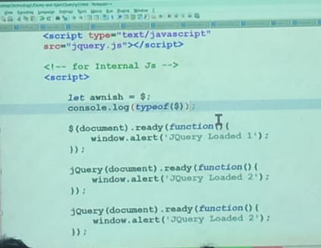

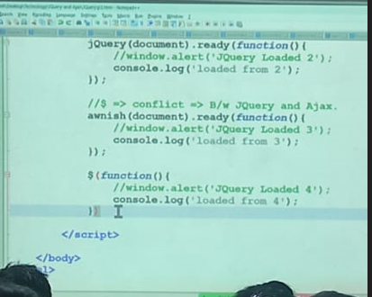

**JQUERY**

**Basic syntax** –

**$(selector).action()**

**Ex.** $(‘#test’).hide();

A $ sign to define/access JQuery

A (selector) to “Query (or find)” HTML elements

A jQuery action() to be performed on the element(s)

**How to use JQuery :**

There are two versions of JQuery for downloading

**.production version** – this is for your live website because it has been minified and compressed.

**.Development version** – this is for testing and development (uncompressed and readable code).

**CSS Use** –

Syntax : **css(“propertyname”, “value”);**

**What are Events ?**

All the different visitor’s actions that a web page can respond to are called events.

An event represents the precise moment when something happens.

**Example** –

* Moving a mouse over an element
* Selection a radio button
* Clicking on an element

**JQuery supports 3 types of** *keyboard events* **and which we are** :

Keyup() : Event fired when a key is released on the keyboard.

KeyDown () : Event fired when a key is pressed on the keyboard.

KeyPress() : Event fired when a key is pressed on the keyboard.

From above difiniations, it looks like that keydown() and keypress() are same thing.

**Toggle Effect** – The Toggle() method toggles between hide() and show() for the selected elements.

**Fading** –

**Syntax** –

*$(selector).fadeOut(speed,callback);*

*$(selector).fadeIn(speed,callback);*

**AJAX**

* **Asynchronous Javascript & XML.**
* Not a Technology
* Sends and Recieves data from Client & Server Asynchronously
* Different than regular HTTP Requests
* Usses **XmlHTTPReques**t Object
* Carries data in XML, Plain text & JSON format
* Does not refresh the browser to receive data from server.
* Jab hum kisi website ko open karte hai (facebook.com) to vo jo request send krti hai 🡪 **Asynchronous** Request kahte hai.
* And jab tak server se response nahi aa jata tab tak vo website unhi refresh (Loading) hoti rahti hai.

🡪 Us website ke load hone that means response aane tak wait karna hi **Asynchronous** kahlata hai.

🡺 **Ajax is a user experience. With the help of ajax we can communicate with server without page reload.**

**Types of AJAX** –

1. Asynchronous Ajax
2. Synchronous Ajax

* Asynchronous ajax call allow the next line of code to execute
* Synchronous call Stop javascript execution until the response from server.

**Ajax Disadvantages –**

It will effect on SEO, because we don’t have specific url’s of page.

**Ajax Example –**

* Facebook like and comments
* Country states and city dropdown.

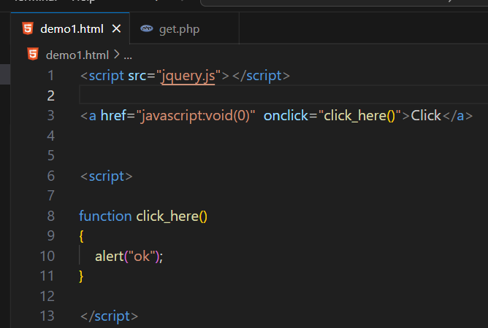

1.

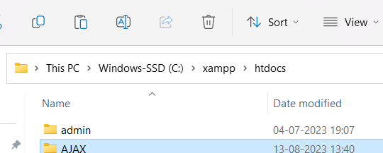

2.

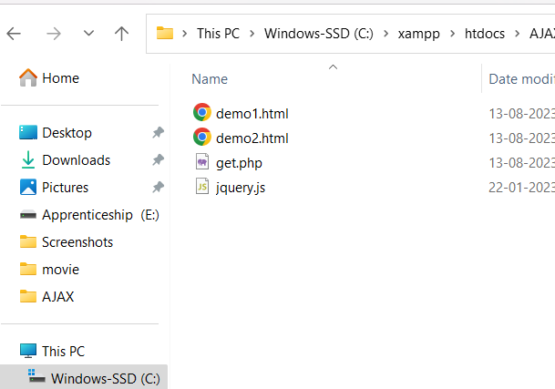

3.

**Calling one page to another page without reload the page.**

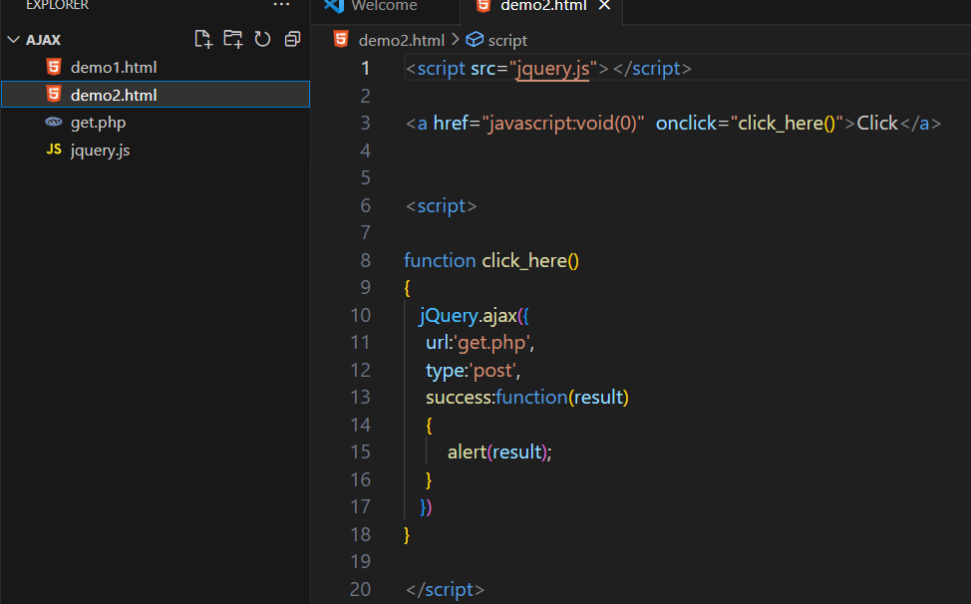

4.

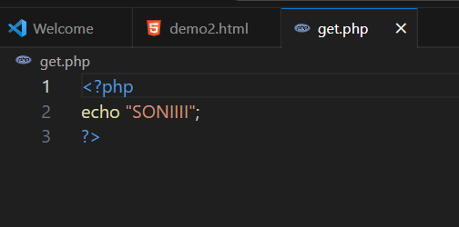

1. Result

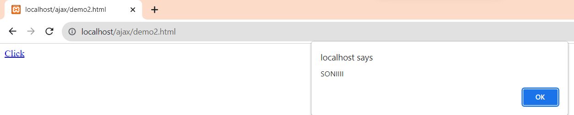

1.

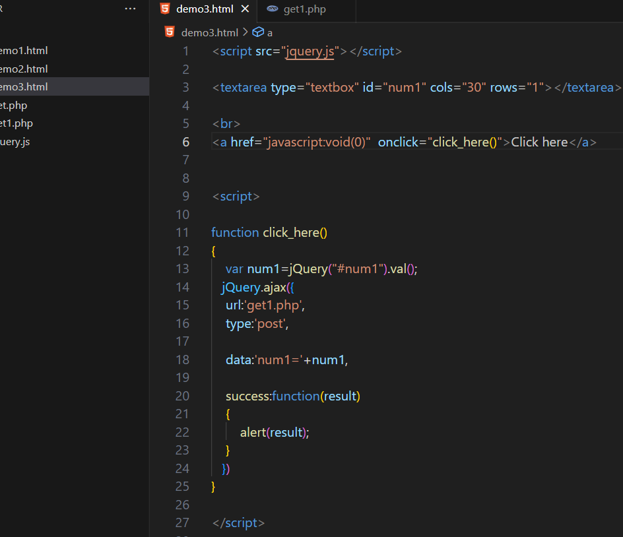

2.

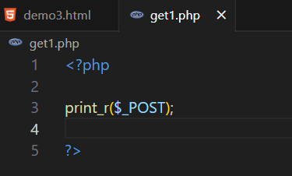

3.

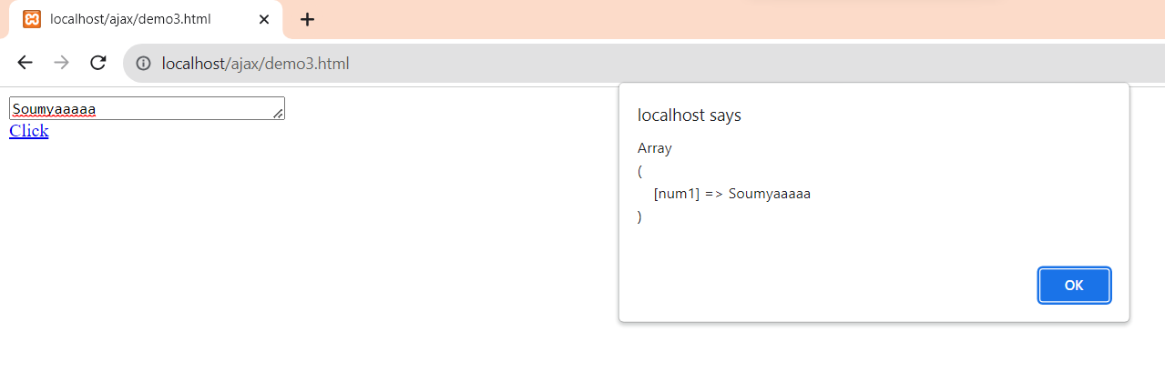

**Fetch JSON Data with the help of PHP and Ajax** –

s